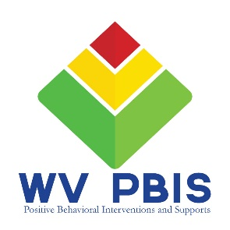
PBIS Virtual Academy 2021
Homework 2.3 - Working Through Acknowledgements and Rewards/Incentives

To recap, the TFI states that for Essential Feature 1.9, Feedback and Acknowledgement:
A formal system (i.e. written set of procedures for specific behavior feedback that is [a] linked to school-wide expectations and [b] used across settings and within classrooms) is in place and used by at least 90% of a sample of staff and received by at least 50% of a sample of students.

This activity is designed to help your team work through a feedback and acknowledgement system that will meet the needs of your students, reinforce positive behaviors, and ultimately lead to positive outcomes throughout your schools.

Step 1:
Watch the “Academy Session 2.3 Homework” video for details and examples.
- You can view the video at this link: https://youtu.be/zIqnQTcPhu8

Step 2: a
Complete the attached activities together.
- Feedback & Acknowledgement Planning
  - You will work through ideas for ways to provide feedback and acknowledge students
- Reward & Incentive Planning
  - You will work through ideas for offering rewards and incentives from earning those acknowledgements

Step 3:
Find Essential Feature 1.9 and review your color coding from your first homework assignment.
- Has anything changed now that you’ve completed these activities?
  - This does not have to be turned in – you’ll complete actual scores on your TFI at a later date.

Be prepared to talk with your BSS about your ideas and to ask any questions you may have about what acknowledgements, rewards, and incentives could be best used at your school.

