Classroom Procedures and Social Emotional Learning
TFI 1.8

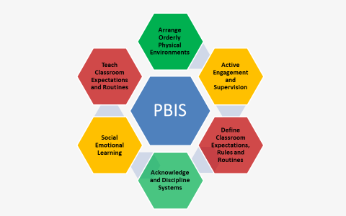

Arranging Orderly Physical Environments
Arranging and organizing the physical space so all students can see, hear, engage, and move freely in order to maximize learning and allow for active supervision.
Active Engagement
Participation off ALL students through strategies and questions to solicit group responses. Lesson plans and instructional strategies so that multiple of students are involved in thinking and problem solving, rather than one at a time.
Active Supervision
A process for monitoring the classroom, or any school setting, that incorporates:

- Moving: Continuous, random teacher movement throughout all parts of classroom.
  - Scanning: Frequent and intentional visual sweep of all parts of classroom.
  - Interacting: Frequent and positive communication to encourage, reinforce, and correct.

* Teacher interacts at least 10 X during a 20-minute observation.
Define Classroom Expectations, Rules and Routines
A continuation of the school-wide teaching matrix. A simple visual tool displaying the established Classroom Expectations, Rules and Routines. A Preventative Prompt (what it looks like to be respectful when…) A critical foundation for establishing consistency among adults.
Acknowledgment Systems
A system that recognizes students for following rules, directives, directions, and participation. Acknowledgments are provided immediate, intermittent, and/or on a long term basis.
Discipline Systems
Pre-plan mild consequences that are delivered consistently, appropriately and unemotionally when a rule is broken by a student.
Social Emotional Learning
The process through which we learn to recognize and manage emotions, care about others, make good decisions, behave ethically and responsibly, develop positive relationships, and avoid negative behavior (Elias, et al., 1997)
Teach Classroom, Expectations and Routines
A lesson plan is a teacher’s daily guide for what students need to learn, how it will be taught, and how learning will be measured.
The most effective lesson plans have five key parts:
- What will I do to explain the topic?
- What will I do to illustrate the topic in a different way?
- How can I engage students in the topic?
- What are some relevant real-life examples, analogies, or situations that can help students understand the topic?
- What will students need to do to help them understand the topic better?

