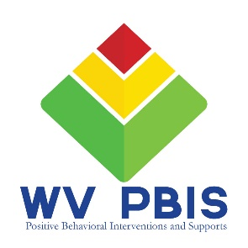
PBIS Virtual Academy 2020
Week 3 Homework - Action Planning

This activity is designed to help your team work through the process of turning your TFI into an Action Plan to move your PBIS program forward throughout the school year.

Step 1:
Gather your materials.
- TFI (booklet or digital copy) and your team’s scores
- Action Planning documents (printed or pulled up on someone’s computer)
- Academy HW Guide and any “Homework” resources uploaded for this week’s sessions
  - Access www.wvpbis.org/virtual-academy/ and click on:
    - Homework Guide 2020
    - Session 3.1 – Classroom Practices/SEL
    - Session 3.2 – Buy-In/PD
    - Session 3.3 – Family, Fidelity, and Figuring It Out

Step 2: a
If you need a review, re-watch the “TFI to Action Plan” video that you watched after your first academy session.
- You can view the video at this link: https://youtu.be/9YX_v6zOtvI

Step 3:
As a team, complete the Action Planning Documents
- Tier 1 Action Plan
  - NOTE: If any Academy homework assignments from “Homework Guide 2020” have not been completed, there should be steps to address/complete them documented in your action plan.
- Professional Development and Involvement Action Plan

Be prepared to talk with your BSS about your action plan as you’re working through it to ensure you’re covering all the necessary topics.

